Payroll Management System for Information Technology Company

Use-Case Specification: View Working-Time

Version 1.0

Revision History

|  |  |  |  |
| --- | --- | --- | --- |
| **Date** | **Version** | **Description** | **Author** |
| 15/12/2019 | 1.0 | Final | Quản Trọng Tú |
|  |  |  |  |
|  |  |  |  |
|  |  |  |  |

Table of Contents

1. Use-Case Name 4

1.1 Brief Description 4

1.2 Actor 4

2. Flow of Events 4

2.1 Basic Flow 4

3. Special Requirements 4

4. Preconditions 5

5. Postconditions 5

6. Extension Points 5

Use-Case Specification: View Working-Time

# Use-Case Name

## Brief Description

This use case defines the step of viewing all user working time. Administrator can easily view all user working time information to have an overview.

## Actor

Administrator

# Flow of Events

## Basic Flow

Administrator click View All button to show all user working time information. If it is null it will show message and if it is empty, table won’t display anything.

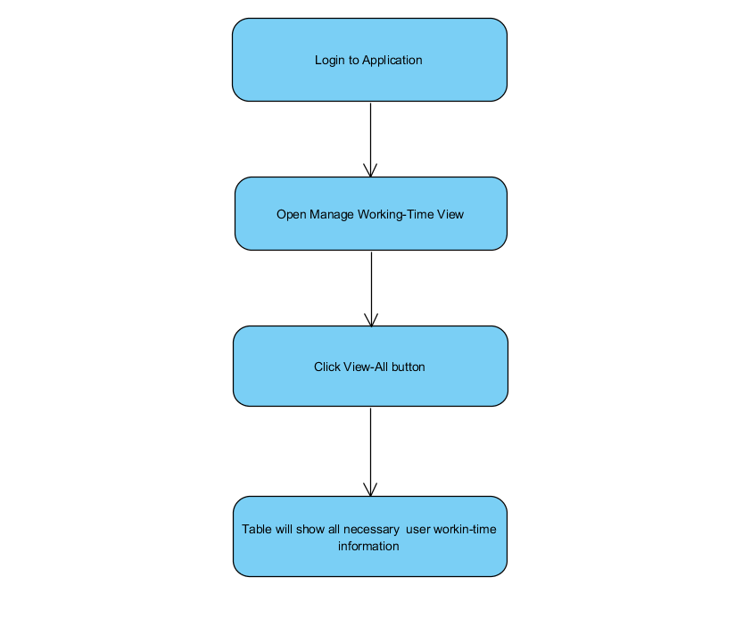

Basic flow of Viewing all user working-time information.

# Special Requirements

No special requirements.

# Preconditions

* Admin have to login into this application and access Manage Working-Time view.

# Postconditions

No post conditions.

# Extension Points

No Extension Points.